Suggested solutions to 2009 RIJC H2 Chemistry Prelim Paper 2

1(a)(i) 1s² 2s² 2p⁵

(a)(ii) [1]
x
y
z

Can also accept p_{x} and p_{y} orbital
Zero mark if all three orbitals are drawn

(b)(i) Include IE data
O: 1s²2s²2p⁴
The 1st IE increases from O to F as the number of protons increases in F but the shielding effect
remains effectively constant.

(b)(ii) O⁺: 1s²2s²2p³
F⁺: 1s²2s²2p⁴
The 2nd IE decreases from O to F due to inter–electronic repulsion between the 2p electrons in F [1]

(c)(i) 2H⁺(aq) + Mg(OH)₂(s) ⎯→ Mg²⁺(aq) + 2H₂O(l) [1]

(c)(ii) Mg²⁺(aq) + 2F–(aq) ⎯→ MgF₂(s) [1]

The Mg²⁺ released from the acid–base reaction in the stomach reacts with the F– present to form
a precipitate of MgF₂ which is insoluble and is thus not easily absorbed by the body.
(c)(iii) Precipitation occurs when
[Mg²⁺][F–]² > K_{sp}
[Mg²⁺]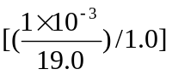² > 5.16 × 10^{–11}
[Mg²⁺] > 0.0186 mol dm^{–3}

(vol. of milk of magnesia needed)(1.40) = (0.0186)(vol. of liquid in stomach)
i.e. vol. of milk of magnesia needed = 0.0133 dm³
(i.e. 13.3 cm³)

2(a) An ideal gas is one which experiences negligible intermolecular forces of attraction and has negligible volume.

OR obeys the ideal gas equation (pV = nRT) perfectly.

(b)(i)
pV
ideal gas
p
0
ammonia
carbon dioxide
[½] – correct shape
[½] – CO₂ above NH₃

(b)(ii) At lower pressures, NH₃(g) deviates from ideal behaviour to a greater extent since it experiences stronger
Intermolecular forces of interaction (hydrogen bonding) as compared to CO₂ (instantaneous dipole−induced dipole interaction).

(c)(i) Lightning OR forest fires OR volcanoes OR other sensible answers.
(but NOT human acts e.g. burning of fuels, combustion engines etc.)

(ii) High temperatures are needed to overcome the strong N≡N.
(d) 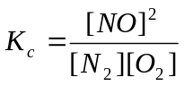 [1]

(e) Let the change in [N₂] be x mol dm⁻³
Eqm concentrations of N₂, O₂ and NO
are 1 – x, 1 – x and 2x mol dm^{–3} respectively.
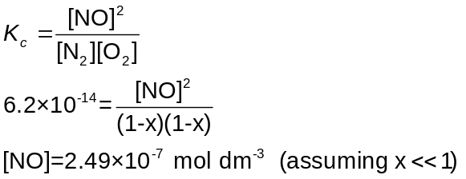

(f)(i) No change
since there are equal numbers of gaseous molecules on either side of the equation.

(Note: a change in volume does not affect such a gaseous system.)

(ii) Position of equilibrium shifts to the right
since there is an increase in concentration of N₂.
By Le Chatelier’s Principle, the system will respond by favouring the forward reaction
and hence the position shifts to the right.

2(g) The system can be treated as the following:

 | N₂ | + O₂ 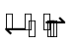 2NO
initial conc. / mol dm^{–3} | (1.0 + 2.0) / 1.5 = 2.0 | 1.0 / 1.5  = 0.666 | –
eqm conc. / mol dm^{–3} | 2.0 – x | 0.666 – x | 2x
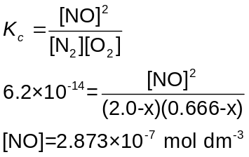

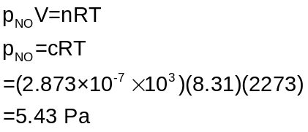

3(a)(i) CaCO₃
CaCO₃ + SO₂ → CaSO₃ + CO₂

(ii) Mass of S in coal = 1 x 10⁹ x 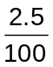 = 2.5 x 10⁷kg = 2.5 x 10¹⁰ g
Amt of S = 2.5 x 10¹⁰ 32.1 = 7.788 x 10⁸ mol
Amt of CaCO₃ = Amt of S = 7.788 x 10⁸ mol
Mass of CaCO₃ = 7.788 x 10⁸ x 100.1 = 7.80 x 10¹⁰ g

(b) Solution F is calcium chloride solution which is effectively neutral.
For BeCl₂, it becomes the aqua complex, [Be(H₂O)₄]Cl₂ upon contact with water. The small,
highly polarising Be²⁺ weakens the O–H bonds of the water molecules in its surrounding sphere of coordination and results in the release of H⁺ (or H₃O⁺) ions in solution, thus giving rise to an acidic solution.
BeCl₂(s) + 4H₂O(l) → [Be(H₂O)₄]²⁺(aq) + 2Cl– (aq)
[Be(H₂O)₄]²⁺(aq) + H₂O(l)[Be(OH)(H₂O)₃]⁺(aq) + H₃O⁺(aq)

(c)(i) CaCO₃ → CaO + CO₂
Amt of CaO = 1.00/100.1 x 56.1 = 0.560 g
(c)(ii)

Mass/ g
1.00

Decomposition curve of CaCO₃

Decomposition curve of MgCO₃
x

time
0

(c)(iii) From Data Booklet

ion | Mg²⁺ | Ca²⁺
Ionic radius | 0.065 | 0.099

The thermal stability depends on the charge density of the cation. The greater the charge density,
the thermally less stable the carbonate.
Since charge density and hence polarsing power of Mg²⁺ is higher than that of Ca²⁺,
the distortion of the electron cloud of the carbonate anion, thus weakening effect of the carbon−oxygen bonds in the magnesium carbonate occurs to a greater extent.
Hence MgCO₃ is more unstable than CaCO₃ and should decompose to MgO and CO₂ at a faster rate
(since its decomposition temperature is lower than that of CaCO₃.)
The mass of MgO obtained is 0.478 g, lower than x (i.e. 0.560 g)

4(a) Structural/positional isomerism
(b) Geometric isomerism

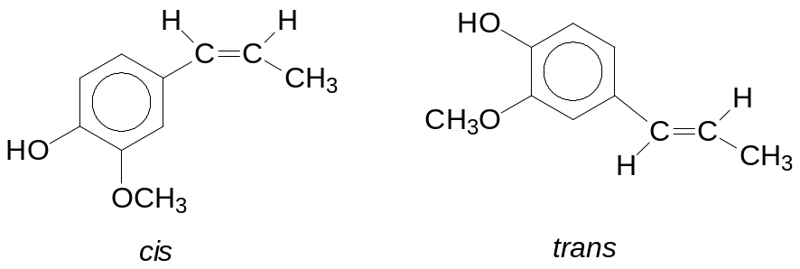

(c) M_{r} of eugenol = 164
M_{r} of vanillin = 152
Amt of eugenol = 16.4 ÷ 164 = 0.100 mol
The theoretical yield = 15.2 g
Percentage yield = 13.0/ 15.2 x 100 % = 85.5 %

(d) Reaction with aqueous NaOH. Acid-base reaction
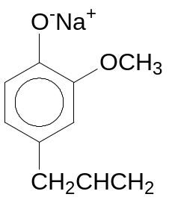
[Other reagents include Na(s), Br₂ (aq) and acid chlorides.]

(e) Add 2,4-DNPH to each compound. Vanillin will give an orange ppt. Or add Tollens’ reagent to each compound and warm [1m for the chemical test]
Vanillin will give silver mirror.
[Use cold alkaline KMnO₄ or acidified K₂Cr₂O₇, heat]
[1m for observation]
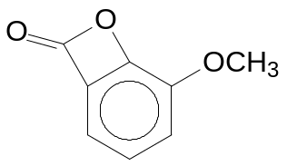

(f)

Compound B
Reasons why the yield may be low:
1. the cyclic ester has ring strain OR
2. phenol is a weaker nucleophile than its phenoxide.

5(a)(i)
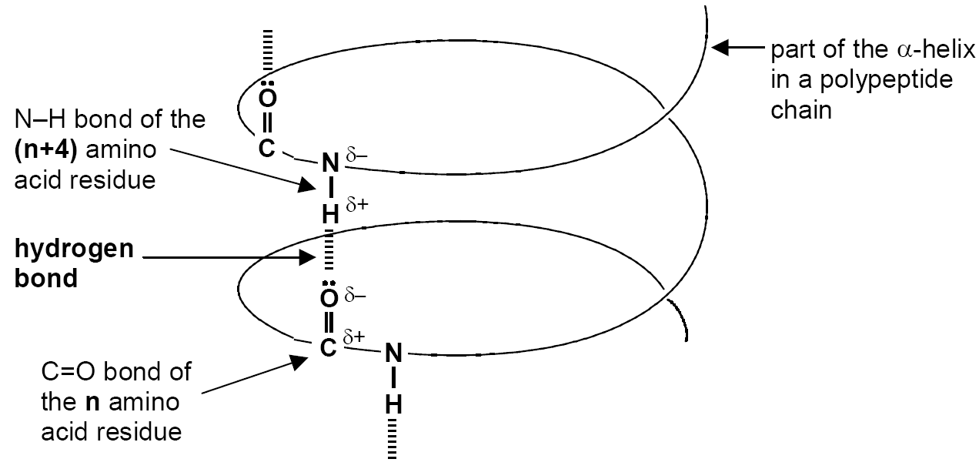
- N–H ---------:O=C
- lone pair on O atom
- δ+ on H and δ– on N
- α-helix

(a)(ii) At temperatures above 60ºC, there is sufficient heat energy to break the hydrogen bonds maintaining the α-helix structure. This causes the α-helix structure to lose its helical shape to become a random coil.

(a)(iii) extreme acidic pH

(b) Primary structure of gastrin:
Glu-Gly-Pro-Gly-Trp-Leu-Glu-Glu-Glu-Glu-Ala-Ala-Tyr-Trp-Met-Asp-Phe

(c) Haemoglobin is a transport protein with quaternary structure. It consists of four polypeptide chains/subunits (specifically, two α-subunits and two β-subunits) combined together to form a globular protein. There is considerable amount of R-group interactions between an α-subunit and the neighbouring β-subunit. Each subunit has a haem group bonded to it. The iron(II) in the haem group can bind to oxygen.

(d) Any three of the following:

Type of interaction | Diagram illustrating the type of interaction
Disulfide bridge/linkage | 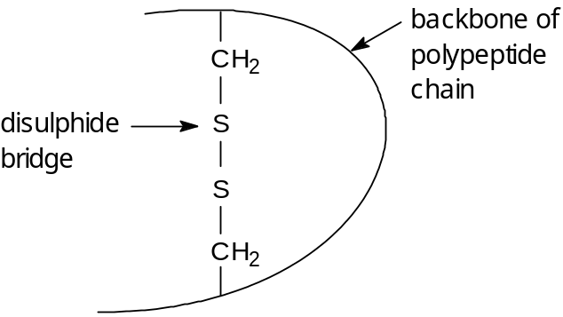
Ionic interaction/  Electrostatic forces of attraction between oppositely charged groups | 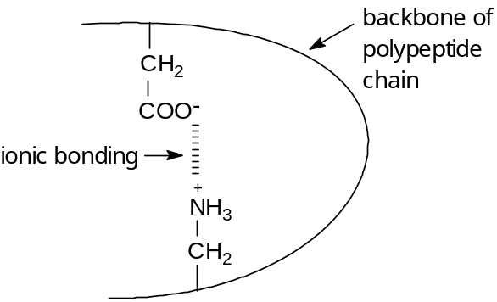
Hydrogen bonding | 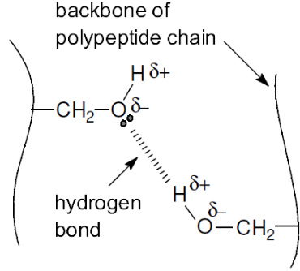  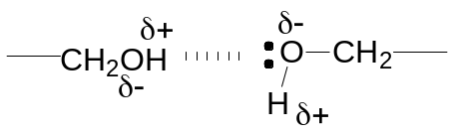  Or  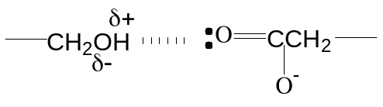
van der Waals’ forces/  hydrophobic forces | –CH₂CH₂CH₃ + any other group e.g.  



